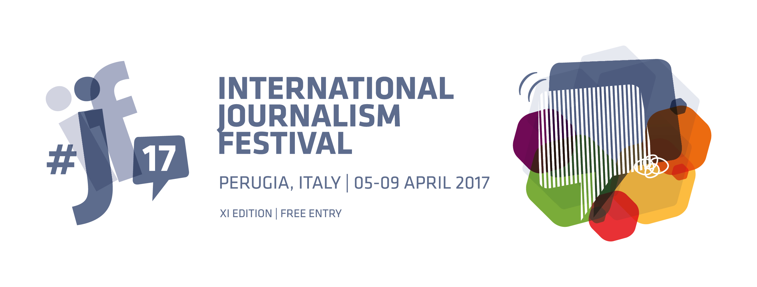

10 March 2017
Perugia
Italy

The 2017 festival – the eleventh edition - will be the biggest and best yet. More than 250 sessions, more than 600 speakers, five full days of high-octane immersion in journalism – in and out of the festival venues – all in the stunning setting of the historic town centre of Perugia.
Each session in eleven different venues will be live-streamed, simultaneous translation in English-Italian will be provided for many.
Festival speakers come from all over the planet. So too the attendees. All festival sessions are free entry for all attendees, without any need for registration.
Festival main sponsors are Amazon, Eni, Facebook and Google. The main institutional partner is the Umbria Regional Council.
Festival sponsors are Ferrovie dello Stato Italiane, Nestlé, Sky and Wordpress. The institutional partner is the Town Council of Perugia.
There are also about a dozen smaller sponsors. We thank all sponsors, big and small, for their support.
About 200 volunteers will take part, involved in activities such as event reviews, speaker interviews, logistics, press office, etc. The volunteers – journalism students, aspiring journalists or journalists at the beginning of their careers – this year come from 27 different countries.
The festival programme is the result of the input of many different individuals, organisations, institutions and media companies. We thank them all for their contribution.
The programme attempts to cover all the major issues of current interest in the media and beyond. We hope you find it stimulating.
What follows is an overview (with session examples for reference) of the festival programme, divided into session categories. For full details please see the online programme.

#ijf17TALKs

Four talks by leading figures on issues of major public interest.

Cameron Barr - Managing Editor, The Washington Post
Covering President Trump: reporting the truth in an era of ‘alternative facts’
moderator Lucia Annunziata
Adam Mosseri - Vice President of Product, Facebook
How News Feed works
moderator Jeff Jarvis
Zaina Erhaim - Institute for War and Peace Reporting
Zaina Erhaim: covering the Syrian war as a journalist, activist and woman
moderator Maria Gianniti
Evan Greer - Campaign Director, Fight for the Future
How we saved Chelsea Manning's life: when activists, lawyers and journalists mobilize together online
moderator Philip Di Salvo

IN CONVERSATION

One-to-one interviews or dialogues on a wide range of subjects. A total of 37 in the festival programme. Here we provide a selection of just 12.

Marcel Rosenbach
A new era of information warfare
with Carola Frediani
Maryam Al-Khawaja, Khadija Ismayilova, Miranda Patrucic
Women on the front line in the fight for freedom of expression
with Marina Petrillo
Feras Fayyad
The last men in Aleppo
with Amedeo Ricucci
Jonathan Albright, Charlie Beckett
Stop worrying about fake news. What comes next will be much worse

Craig Newmark
Without trust in the media, democracy is doomed
with Mario Calabresi
Hossein Derakhshan, Mathew Ingram
How to fight back against big data
with Fabio Chiusi
Richard Gingras
Role of digital companies in the evolution of news publishing
with Davide Casati
Aron Pilhofer, Dave Winer
Plan B: making a home for news on the open web

Owen Jones
The crisis of capitalism
with Fabio Chiusi

Mohamedou Ould Slahi
My 15 years without charge in Guantanamo Bay
with Barbara Serra, Larry Siems
Mark Thompson
Enough said. What’s gone wrong with the language of politics?
with Mario Calabresi
Ece Temelkuran
Truth is a lost game in Turkey. Don’t let the same thing happen to you
with Marta Ottaviani
THEATRE SHOWS
An opportunity to end the day with music and entertainment. There are 7 such shows in the festival programme. Here is one example.
Alaa Arheed, Isaac De Martin and the Adovabadàn Jazz Band
Strong hands: we'll tell you about Syria... with music

PANEL DISCUSSIONS
A grand total of 112 panel discussions on many different subjects are offered in the festival programme. Panels are composed of from two to four (and very occasionally five) speakers plus moderator. A very broad range of speakers is involved. We provide here a small representative sample.
‘Fake news’ and the misinformation ecosystem
Aine Kerr, Mark Little, Alexios Mantzarlis, Craig Silverman, Claire Wardle
Reporting emerging authoritarianism
Yavuz Baydar, Tamas Bodoky, Alexa Koenig, John Nery
How digital can save journalism in the Middle East and Arab World
Sakhr Al-Makhadhi, Fatemah Farag, Sana Sbouai, Farah Wael
The ethics of live video
Ben de Pear, Mark Frankel, Joanna Geary, Mandy Jenkins, Sue Llewellyn
Something old, something new: digital media and the coverage of climate change
Milene Larsson, Stuart Millar, James Painter, Akshat Rathi
How to tackle trolls and manage online harrassment
Mary Hamilton, Alexandra Pascalidou, Julie Posetti, Hannah Storm
The rise of live journalism
Yoeri Albrecht, Joris Luyendijk, Florence Martin-Kessler, Jakob Moll, Sameer Padania
News beyond advertising
Renee Kaplan, Turi Munthe, Rasmus Nielsen, Aron Pilhofer, Vivian Schiller
Hacking democracy? Russian hackers, Wikileaks, propaganda, US elections
Lorenzo Franceschi-Bicchierai, Carola Frediani, Stefania Maurizi, Andrei Soldatov
Towards a relationship of trust: journalism, philanthropy and newsroom independence
Ludovic Blecher, Maria Teresa Ronderos, Nienke Venema, Rob Wijnberg
Investigating big data: collaboration and best practice
Anna Babinets, Mar Cabra, Nicolas Kayser-Brill, Stuart Millar, Richard Sambrook
Improving news literacy through collaboration
Charlie Beckett, Dan Gillmor, Mary Hamilton, Aine Kerr
Investors in independent media
Mariano Blejman, Turi Munthe, Sameer Padania, Victoria Powell, Ross Settles

Communicating the news to young people
Mathew Ingram, Jeff Jarvis, Lucy Marcus, Maximilian Wolff (age 10)

In addition to the above, the programme also offers a total of 13 sessions specific to the subjects of Data Journalism and Engagement.

WORKSHOPS

A set of 37 workshops to choose from, including 5 workshops run by Google, 5 by Facebook and 3 by First Draft Media. There are also 7 sessions in the Hackers’ Corner.

PRESENTATIONS
There are 21 presentations in the festival programme. We highlight here 6 for reference.

#Hacked: Al Jazeera's interactive news game on Syrian cyberwar
with Julian Ruhfus
Google Accelerated Mobile Pages
with Luca Forlin
Algorithm tips: how to investigate government algorithms
with Nicholas Diakopoulos
Wordpress, the opportunities of the open web
with Luca Sartoni
Football Leaks and Panama Papers: two tales of great journalism
with Mar Cabra and Stefan Candea
InnovateAFRICA: million-dollar fund for media innovation in Africa
with Justin Arenstein and Joyce Barnathan
DOCUMENTARIES

including

I love Dick (the first two episodes of the new series)
organised in association with Amazon.
Nobody speak
organised in association with Netflix.
with an introductory interview of Lisa Nishimura, Vice President of Original Documentary for Netflix, by Mario Calabresi.

BOOKS

There are 13 book presentations, of which we highlight one.

Journalism after Snowden: the future of the free press in the surveillance state edited by Taylor Owen and Emily Bell (2017)
with Charlie Beckett, Janine Gibson, Dan Gillmor and Taylor Owen

